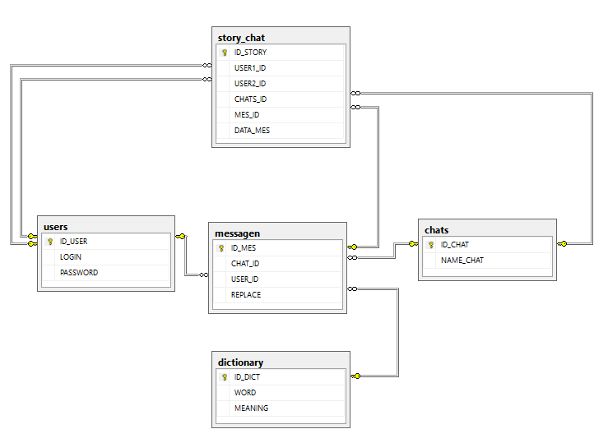

SET ANSI_PADDING ON

GO

SET ANSI_NULLS ON

GO

SET QUOTED_IDENTIFIER ON

GO

CREATE DATABASE chat

GO

USE chat

GO

CREATE TABLE chats /*Чаты*/

(

[ID_CHAT] INT NOT NULL IDENTITY(1,1),

[NAME_CHAT] VARCHAR(100) NOT NULL,

CONSTRAINT [ID_CHAT] PRIMARY KEY CLUSTERED

([ID_CHAT] ASC) ON [PRIMARY]

)

GO

CREATE TABLE users /*Пользователи*/

(

[ID_USER] INT NOT NULL IDENTITY(1,1),

[LOGIN] VARCHAR(50) NOT NULL,

[PASSWORD] VARCHAR(50) NOT NULL,

CONSTRAINT [ID_USER] PRIMARY KEY CLUSTERED

([ID_USER] ASC) ON [PRIMARY]

)

GO

CREATE TABLE dictionary /*Словарь*/

(

[ID_DICT] INT NOT NULL IDENTITY(1,1),

[WORD] VARCHAR(150) NOT NULL,

[MEANING] VARCHAR (150) NOT NULL,

CONSTRAINT [ID_DICT] PRIMARY KEY CLUSTERED

([ID_DICT] ASC) ON [PRIMARY]

)

GO

CREATE TABLE messagen /*Сообщения, строка ввода*/

(

[ID_MES] INT NOT NULL IDENTITY(1,1),

[CHAT_ID] INT NOT NULL,

[USER_ID] INT NOT NULL,

[REPLACE] INT NOT NULL,

CONSTRAINT [ID_MES] PRIMARY KEY CLUSTERED

([ID_MES] ASC) ON [PRIMARY],

CONSTRAINT [FK_ID_CHAT] FOREIGN KEY ([CHAT_ID])

REFERENCES chats ([ID_CHAT]),

CONSTRAINT [FK_ID_USER] FOREIGN KEY ([USER_ID])

REFERENCES users ([ID_USER]),

CONSTRAINT [FK_ID_DICT] FOREIGN KEY ([REPLACE])

REFERENCES dictionary ([ID_DICT])

)

GO

CREATE TABLE story_chat /*История чата*/

(

[ID_STORY] INT NOT NULL IDENTITY(1,1),

[USER1_ID] INT NOT NULL,

[USER2_ID] INT NOT NULL,

[CHATS_ID] INT NOT NULL,

[MES_ID] INT NOT NULL,

[DATA_MES] DATE NOT NULL,

CONSTRAINT [ID_STORY] PRIMARY KEY CLUSTERED

([ID_STORY] ASC) ON [PRIMARY],

CONSTRAINT [FK_ID_USER1] FOREIGN KEY ([USER1_ID])

REFERENCES users ([ID_USER]),

CONSTRAINT [FK_ID_USER2] FOREIGN KEY ([USER2_ID])

REFERENCES users ([ID_USER]),

CONSTRAINT [FK_ID_CHATS] FOREIGN KEY ([CHATS_ID])

REFERENCES chats ([ID_CHAT]),

CONSTRAINT [FK_ID_MES] FOREIGN KEY ([MES_ID])

REFERENCES messagen ([ID_MES])

)

GO